Communication Plan Purpose & Scope

The main purpose and objective of the Contact Center Project are to improve the communication process for planning support calls and inquiries from different store locations. This process will help reduce stakeholders' workload, save time, and enhance service quality. The project aims to raise public awareness about information sharing, project roles and responsibilities, distribution frequency, and distribution responsibilities. Considering several factors while preparing a communication plan is important, such as stakeholder and general requirements, asset availability, and project goals and objectives. The provided information should be clear, accurate, and easy to understand. Hence, the scope of the project will include stakeholder roles, communication methods, types of communication and information, communication channels, conducting training, gathering feedback, and keeping track of records and reports to improve efficiency. The data considered in the plan is crucial for various purposes such as simplifying communication, improving customer service efficiency, reducing burdens, enhancing efficiency, boosting asset management, and supporting technical data and information. In the communication plan, several constraints are identified, including limited resource availability, staff constraints, and restricted funds for training sessions. It's imperative to mitigate or eliminate these constraints to ensure the success of the communication plan.

Communication Plan Execution

The communication plan explains the steps and processes involved in stakeholders' communication and how they communicate. The project manager is responsible for the overall health and safety of the project and, hence, will be the primary and important communicator of the project. The communication plan will be executed according to the steps mentioned in the communication matrix. The stakeholders can send messages to other stakeholders regarding roles and responsibilities, and the project manager will ensure that the messages align accurately with the project's goals and scope. Then, the project manager will work with the respective teams and finalize messages before they are sent out to the respective parties. Hence, the project manager is responsible for identifying different communication methods, ensuring everyone has access to the required information. All directors, supervisors, and team leaders should ensure that the correct and accurate information has been used by their team and communicated through the channels noted in the communication matrix.

The project manager monitors action items and follows up with the team, escalating issues if the communication matrix and methods are not followed. The Project Manager or the director of each team or department will maintain a risk register and issue a risk mitigation plan via various communication channels to the team. The communication matrix will consist of messages, medium, frequency, documentation, strategy, barriers, etc. These will help the project manager create a transparent message and ensure all stakeholders receive the necessary information, reducing misunderstandings and miscommunication. Hence, cooperation and transparency in communication are crucial for the success of any communication plan in an organization.

Communication Matrix

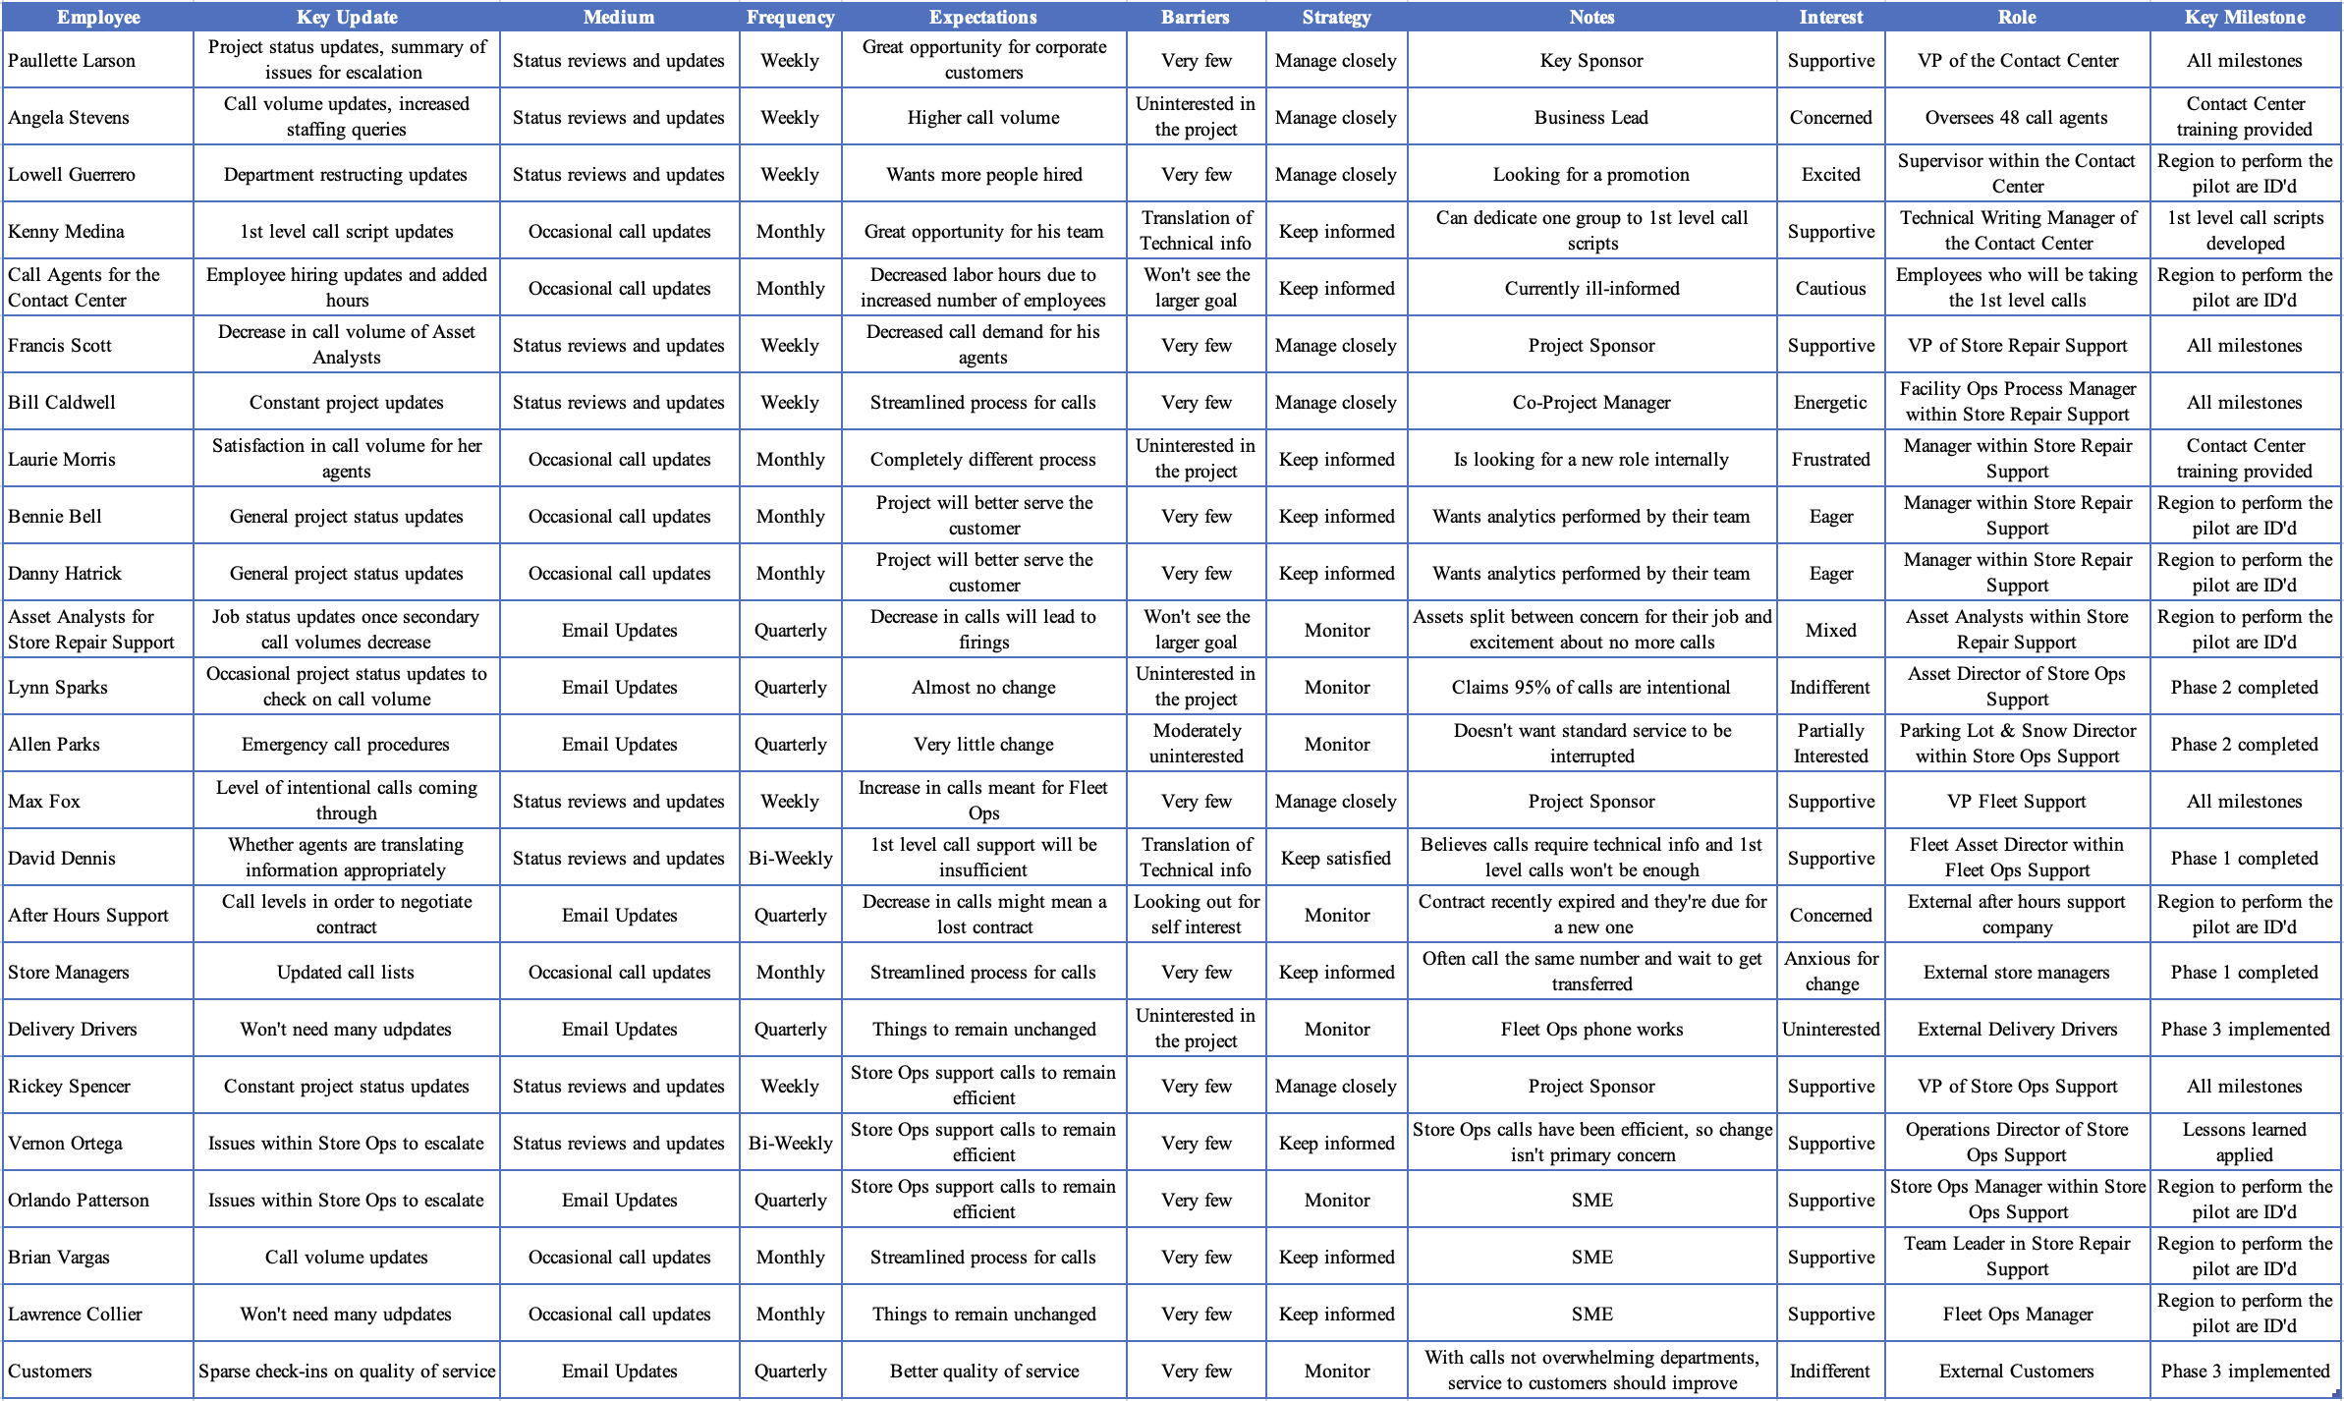

Meeting Guidelines

The following meeting guidelines are for this communication plan:

* All parties are expected to join the meeting on time, whether in person or remotely.
* If remote, always have your camera on.
* At the beginning of the meeting, each person should introduce themselves by name and position.
* A week before the meeting, the agenda and any necessary documentation should be distributed so all parties have access.
* All parties are expected to review and come to the meeting prepared to discuss and ask questions.
* Meeting minutes will be made available 24 hours after the meeting and stored in a shared platform.
* Any actionable items will be assigned within 24 hours after the meeting.
* Every person should feel comfortable speaking as well as being an active listener.

Presentation Guidelines

The following recommendations are guidelines for presentations:

* Understand your audience
* Use appropriate language
* Be clear and concise
* Speak slowly
* Be prepared for questions
* All formatting should be consistent
* Engage your audience

Report Formats / Templates

**Meeting Minutes Template:**

|  |  |
| --- | --- |
| Meeting Date |  |
| Meeting Time |  |
| Meeting Location |  |
| Attendees |  |
| Minutes Issued By |  |

|  |  |
| --- | --- |
| Topics of Discussion: | 1 |
|  | 2 |
|  | 3 |
|  | 4 |

|  |  |
| --- | --- |
| Action Items: | 1 |
|  | 2 |
|  | 3 |

**Project Status Template:**

|  |  |
| --- | --- |
| Last Week | |
| Completed | 1 |
|  | 2 |
| Needs Work | 1 |
|  | 2 |
| Summary |  |
| This Week | |
| Completed | 1 |
|  | 2 |
| Needs Work | 1 |
|  | 2 |
| Summary |  |
| Next Week | |
|  |  |

Glossary

**Employee:** The particular stakeholder

**Key Update:** An important piece of information specific to the stakeholder.

**Medium:** The method or channel used to convey information, such as email, meetings, or reports.

**Frequency:** The regularity or occurrence of an event, task, or communication, often expressed in terms of time intervals.

**Barriers:** Obstacles or challenges that impede the smooth flow of communication or the achievement of project goals.

**Strategy:** A plan or approach designed to achieve specific objectives or outcomes, often in the context of project management.

**Notes:** Brief comments, observations, or additional information related to a particular topic or communication

**Interest:** The level of engagement a stakeholder has in the project.

**Role:** The position a person holds within their organization.

**Key Milestone:** The significant point in the project that is relevant to a particular stakeholder.

References

Bolick, Chris. (2019). Contact center case study. *PJM 6210-Communication Skills for Project Managers | Northeaster University, pgs. 1-13.*